Blinking Printer Lights

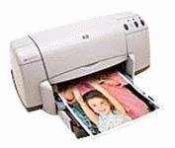

You are experiencing the problem of blinking lights with your HP DeskJet 920C printer: The Power light blinks but the Cartridge & Resume lights are off. This happens when the printer is NOT currently processing a print job.

Go to www.hp.com, and consult their knowledgebase to find out how to solve this problem. Use a time-piece to track precisely how long it takes from the moment the hp home page loads until the solution is found.

1. How long did it take?
2. Document your navigation (“click”) path.
3. Copy and paste your finding: the instructions for fixing the problem